University of California D. Steigerwald
Department of Economics
Economics 241B

Exercise 5

- We will investigate the following claim (which appears in nearly this form in Studenmund)

If an equation that contains a lagged dependent variable as a regressor has a serially correlated error term, then OLS estimates of the coefficients will be inconsistent.

To investigate, we define a regression model in a slightly different way. Let be a strictly stationary and ergodic random variable that is observed into the infinite past. Assume that 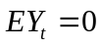 and 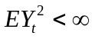. Define
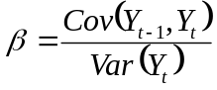
and 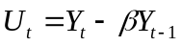 so that we can write
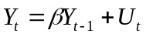for t=1,…,n.

a. Show that 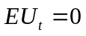and 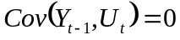.

- Show that the OLS estimator B from a regression of on 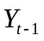, for t=1,…,n, is consistent for β.

- Show that, without further assumptions, 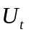 is serially correlated.

- What do you conclude about the validity of the quotation?

- Stochastic Processes - Consider two sequences formed from the i.i.d. mean zero finite variance sequence 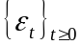. The first is 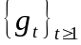 formed as

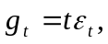

the second is 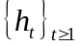 formed as

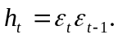

- Determine if each sequence is independent and identically distributed ( i.i.d.).

- Determine if each sequence is a stationary martingale difference sequence (m.d.s.).
- Determine if each sequence is white noise.

3. Martingale Sequences

You join a research project designed to predict stock prices. One member of your team, using previous research proposes a regression analysis of the form:

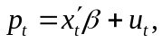

where 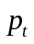 measures the stock price for period t and the regressors include lagged values of both firm characteristics, such as research and development expenditures, and the stock price. Let 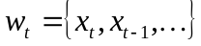 be the information set that consists of the current and all past values of the regressors.

a. In one discussion, you state that the stock price, , is a martingale with respect to 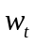. Your colleagues ask you not only to define what it means for the price to be a martingale, but also to explain what implications your martingale statement has for the proposed regression analysis. Please respond.

b. The second stage of the analysis is to predict future prices and, hence future price changes, given . What prediction of future prices results from the martingale model? What is the corresponding prediction for future price changes?
(Hint, use the Law of Iterated Expectations to determine 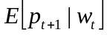 to begin.)

- Upon hearing of your results, another researcher remarks that he understood that stock prices follow a random walk. He states that the results you found confirm his understanding, as the statement that stock prices are a martingale (with respect to ) implies that stock prices are a random walk. The other researchers turn to you to assess the accuracy of this statement. Please respond.

4. Computational Exercise

Return to the paper by Charness and Kuhn listed on the syllabus. Write programs in both Matlab and Stata (the results from each program should match) that again estimate the models in columns (6) and (7) of Table 3 of Charness and Kuhn. Calculate cluster-robust standard errors (so your estimated standard errors should match those in the table). Test the hypothesis that all four slope coefficients are equal and provide the p-value for the estimated test statistic.

